## **Section-End Project - Lesson 1**

## **Spring Boot MVC II**

## **Login Controller**

Instructions:

1. Create a Spring Boot Starter project with a Spring Web dependency.

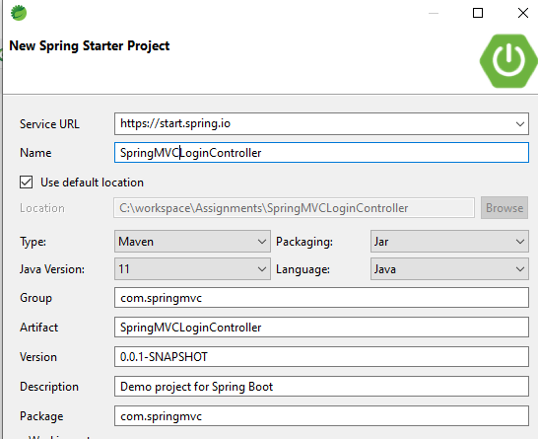

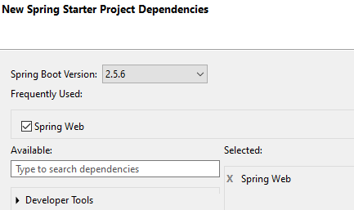

1. Create a Bean called LoginBean in a package nemed model under com.springmvc with 2 private fields :

private String userName;

private String password;

Add appropriate getters and setters.

1. Create the LoginController class as below.

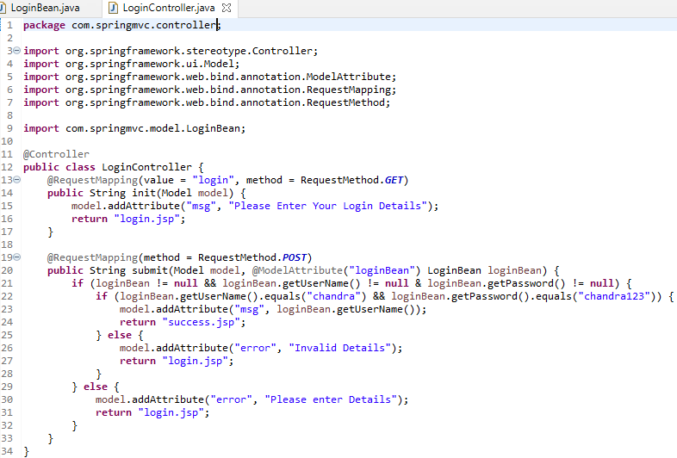

1. Crete the following folder structure for the web pages:

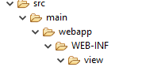

1. Place showMessage.jsp the view folder:

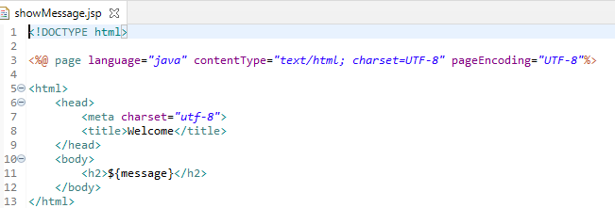

1. The next 3 jsps go directly under the webapp directory:

**index.jsp**

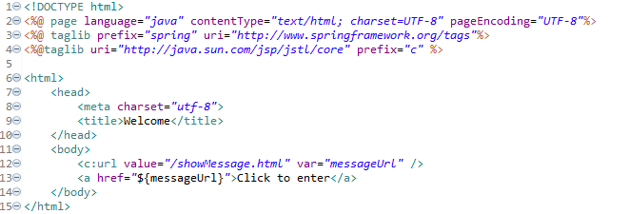

**login.jsp**

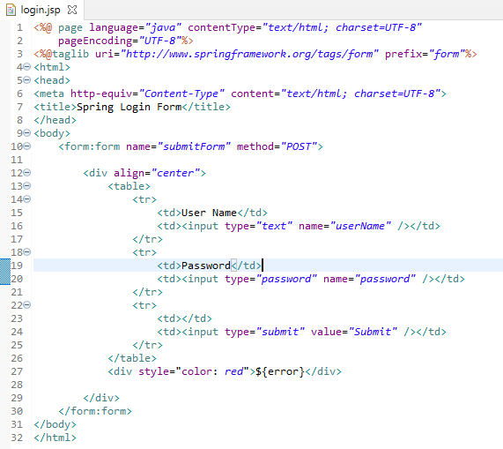

**success.jsp**

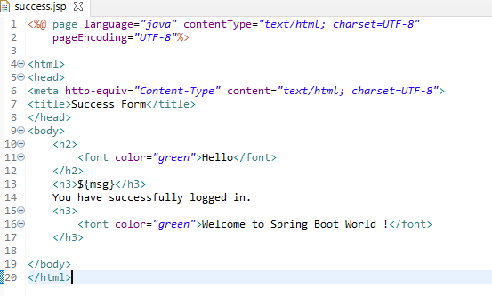

1. Add the following to application.properties:



1. Run the application. Output should be as below:



